Here are some finding when I tried to run your code. Maybe the file and data name regulation will be much easier and clear if you make some changes to that.

1. In the cleaned data folder, there are both processed data visualization output, which makes importing file a little bit confusing. Also, as you may notice, because there will be plenty of data loaded but with quite identical name, this part, when you try to join the parcel with buffer, it shows the buffer hasn’t been loaded before. In this way, make a relatively clean dataloading section is necessary. Here’s one example I found that might be useful for you. Make sure using comments and line breaks.

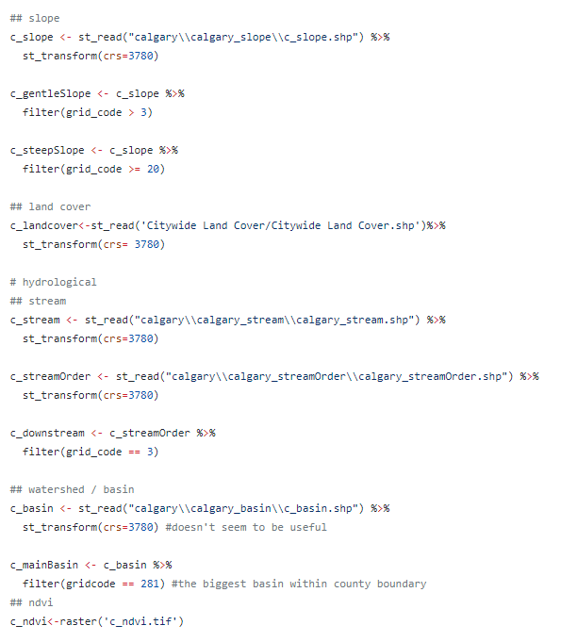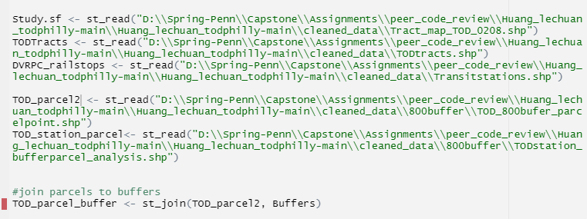

1. When you try to create buffer, I see there is a list of “TOD_parcel_buffer” you create, it is appropriate in the process,since it’s hard to get to the final stage at once. But when you finish the exploratory work, it may be helpful to clean the stage and create a distinguished buffer, so that you won’t be confused in future work.
2. I’m looking forward to see the interesting analysis you mentioned in your report 😊